**Consumer Health Portal**

* Use cases:
  + Track Statistics of Wearable devices
  + Gain access to the medical records and engage with medical providers
  + Enter time and doses of medications which can be used to refill or self-tracking of medications
  + Interact with Health Coach
* Users Involved
  + Consumer:
    - Wearable Devices
    - Smart Phone
  + Hospital
    - MRS
  + Pharma
    - Pharma Order System
  + Health Coach/Gym
    - Smart Phone
* Architecture 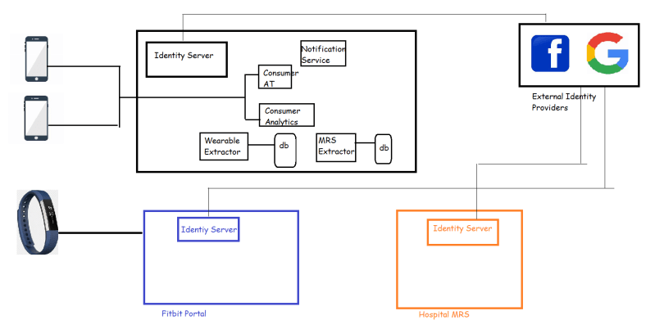
* Reference Architecture in Azure 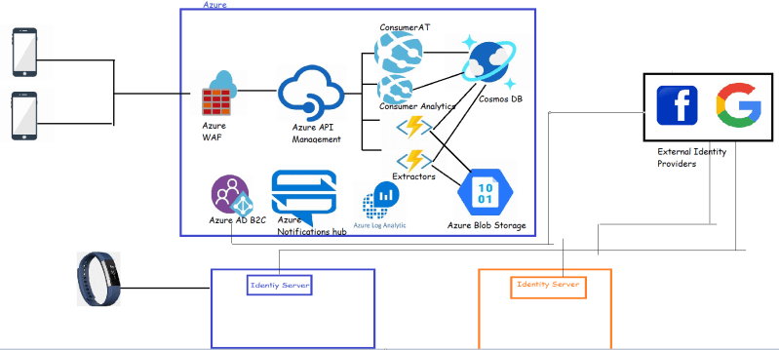
* Reference Architecture in AWS 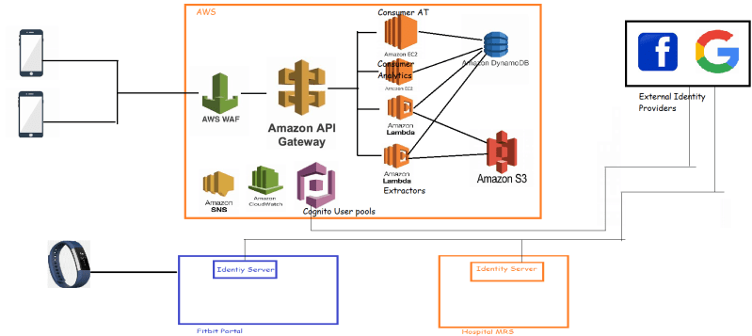

**Ticketing Platform**

* Architecture 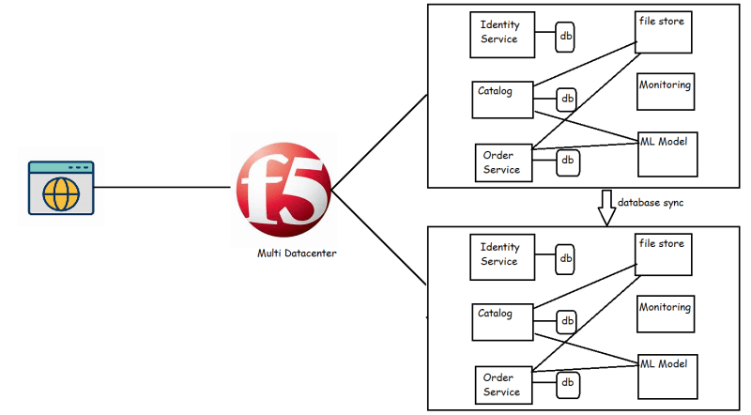
* Reference Architecture in Azure 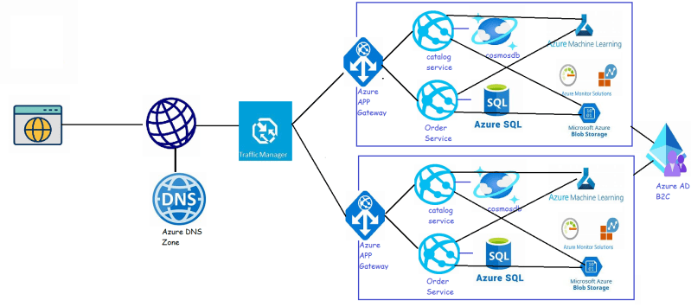
* Reference Architecture in AWS 